Human Aspects Assignment - Human Centred Computing

In Class

While playing Super Smash Ultimate with two different controls I found out that I couldn’t do a specific action with one of the controls(*Figure 1*), the Joy-Con. The layout of the Joy-Con control prevented me from mashing(pressing the button really fast) the A, B, X, Y buttons when I needed to. On the pro controller I have a better grip on the controller and since the button are diagonally away from the thumb stick its not it the way for my thumb to mash.

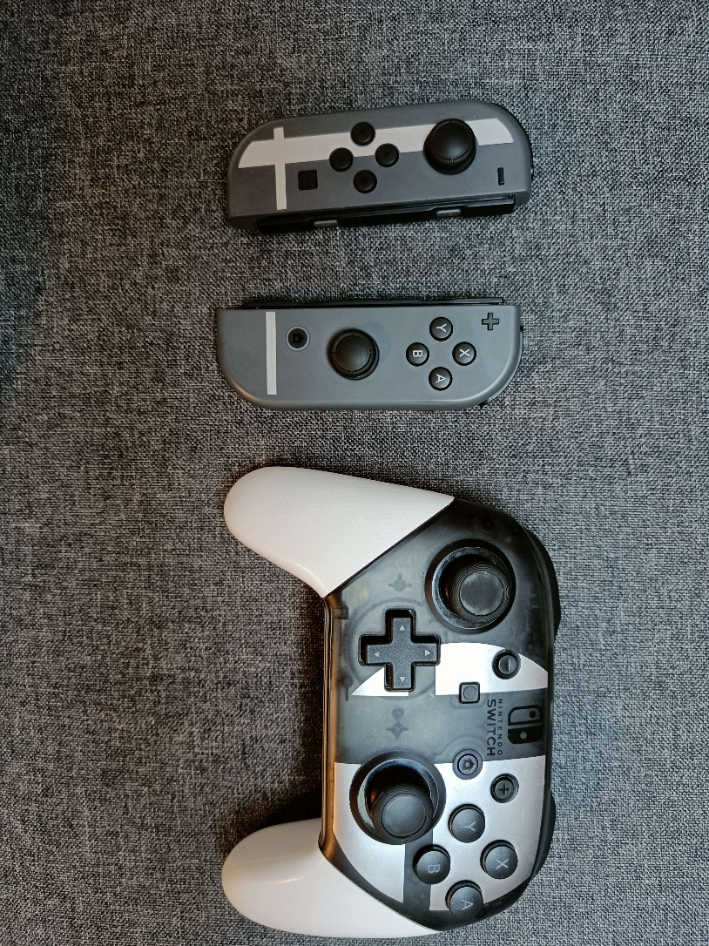

Figure Left Joy-Con Right pro controller

In World of Warcraft Priming is a big part of big group fights. Before you fight a boss a bunch of weaker enemies are before the boss room and they use some of the abilities the boss uses. This way you can prime the player to get used to the boss mechanics.

Another World of Warcraft example is about Grouping. In one dungeon you need to recognise the missing pattern between 4 symbols(*Figure 2*). The options are (no)circle + leaf or flower + (not)filled. You can only see one of the 4 symbols at the time and you need to be fast, since it is a timed event. Personally I solve this puzzle by chunking the symbols. Chunks:

Circle + leaf/flower + filled = full leaf/flower.

Circle + leaf/flower + not filled = empty leaf/flower.

No circle + leaf/flower + filled = filled leaf/flower.

No circle + leaf/flower + not filled = leaf/flower.

A friend of mine does it by assigning bit codes to them. Example: circle/type/filled. Yes circle + flower + filled = 101

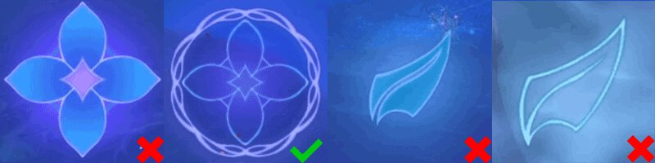

Figure https://www.icy-veins.com/wow/mists-of-tirna-scithe-dungeon-guide

Not in class

In many games there are different objects to achieve for this it is very advantageous if there is a good task structures. Many games do this by having a map(Figure 3) with visual objects and if you hover over the objective you gain some information of how to complete this. Furthermore there is most likely a quest log available with more long term objectives. Now not all games use task structures. For example Dark Souls/Elden ring is notorious for not using them. To such an extend that when Elden Ring was release some game developers proclaimed that it was one of the worst UI experiences ever. But even do that might be the case it is one of the best games of the year. So something like a task structures is not always needed.

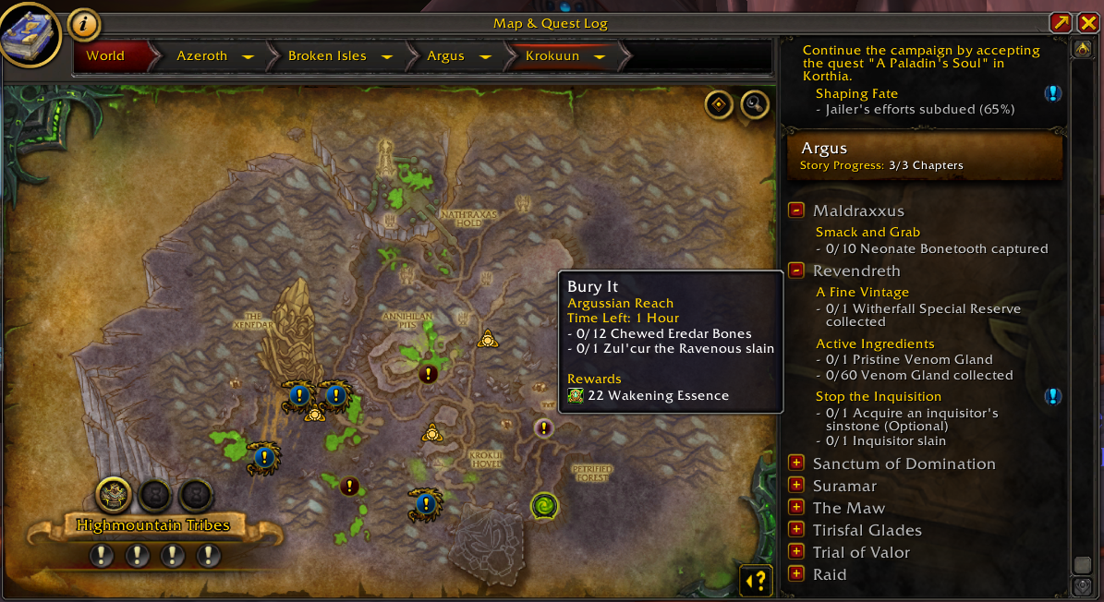

Figure World of Warcraft Area map with objectives + quest log on the right

